UNDERSTANDING AND MAINTANCE OF NETWORK

Assignment day-2
TASK1: Draw a labelled diagram of a typical home WiFi router and a network switch, clearly marking at least 3 different ports (such as WAN, LAN, Console) and the location of status LEDs.

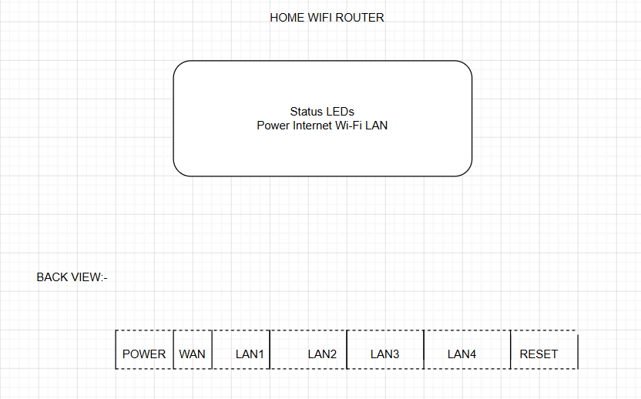

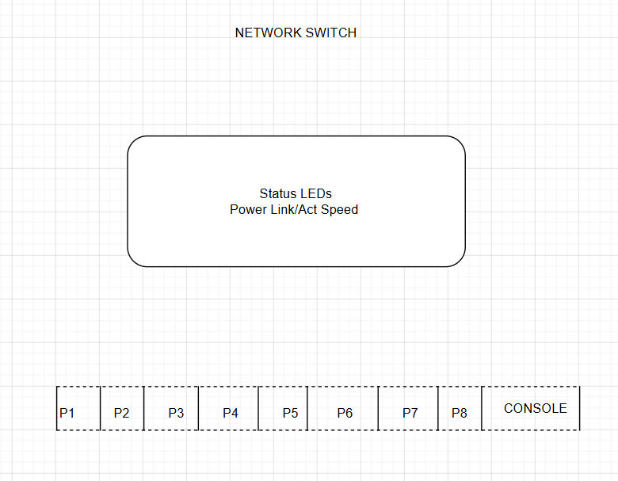
TASK2: List 3 key differences between routers and switches in terms of their main functions and how they handle network traffic.<br><br><em><strong>Hint:</strong> Think about how each device deals with IP addresses, MAC addresses, and the types of networks they connect.</em>

Router | Switch
Connects different networks (LAN to Internet). | Connects devices within the same LAN.
Uses IP Addresses to forward data. | Uses MAC Addresses to forward data.
Shares Internet between devices. | Transfers data between connected devices efficiently.

TASK3: Take a real or virtual image of a router and a switch (from your home, lab, or Google Images), and identify the following on each: Power port, at least 2 Ethernet ports, and any LED indicators. Annotate the image or describe their position and purpose.

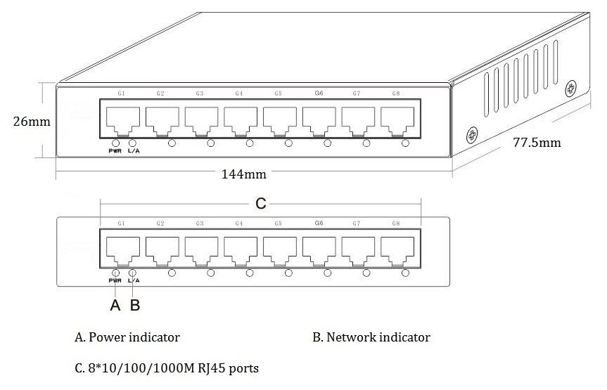
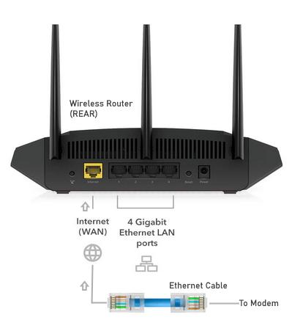
Router
Power Port
- Located on the back.
- Used to connect the power adapter.
WAN Port
- Usually a blue or yellow port.
- Connects to the modem/ISP.
LAN Ports
- Usually 4 Ethernet ports.
- Connect desktop PCs, printers, or switches.
LED Indicators
- Located on the front.
- Show Power, Internet, Wi-Fi, and LAN status.
Switch
Power Port
- Located on the back or side.
- Supplies power to the switch.
Ethernet Ports
- Located on the front.
- Connect computers, printers, and other network devices.
Console Port
- Used for configuring managed switches.
LED Indicators
- Above each Ethernet port.
- Show link status and data activity.

TASK4: Imagine you are setting up a small gaming café network for IPL streaming and multiplayer matches. Write a short scenario explaining which device (router or switch) you would connect first to the ISP line, and how you would connect 8 gaming PCs to the network. Justify your choices.

A small gaming café has 8 gaming PCs for multiplayer games and IPL live streaming.
First, the ISP Internet cable is connected to the Router because the router connects the café to the Internet and provides IP addresses to all devices.
Next, one LAN port of the router is connected to an 8-port Network Switch.
Finally, all 8 gaming PCs are connected to the switch using Ethernet cables.
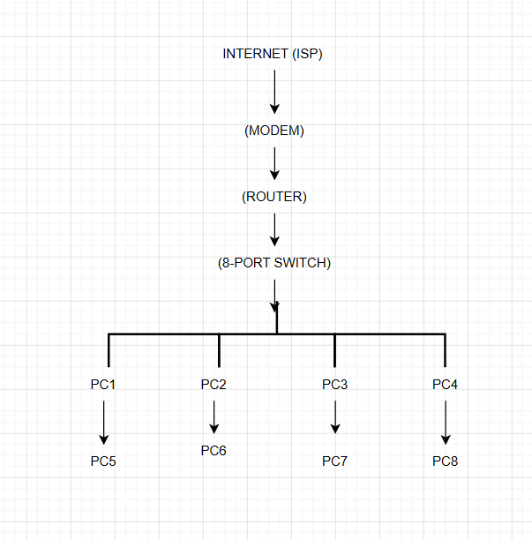
Router is connected first because it provides Internet access, assigns IP addresses, and manages traffic between the local network and the Internet.
Switch is connected after the router because it allows many wired devices to communicate efficiently within the local network.
Ethernet cables are used for all gaming PCs because wired connections provide low latency, high speed, and stable performance, which are essential for online gaming and HD IPL streaming.

